**Module 3 Activity 2: Understanding MongoDB**

Naga Sumanth Vema

IFT 554: Middleware Programming & Database Security

Dinesh Sthapit

February 18th, 2024

**Module 3 Activity 2: Understanding MongoDB**

Screenshot 1: of your project folder structure and package.json file.

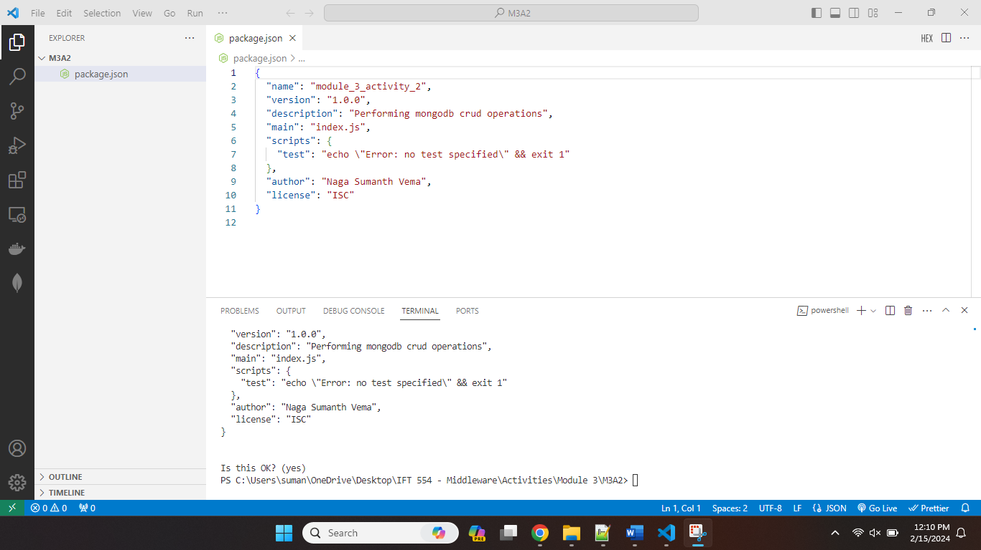

Screenshot 2: of your MongoDB Atlas dashboard showing the created cluster and the connection string.

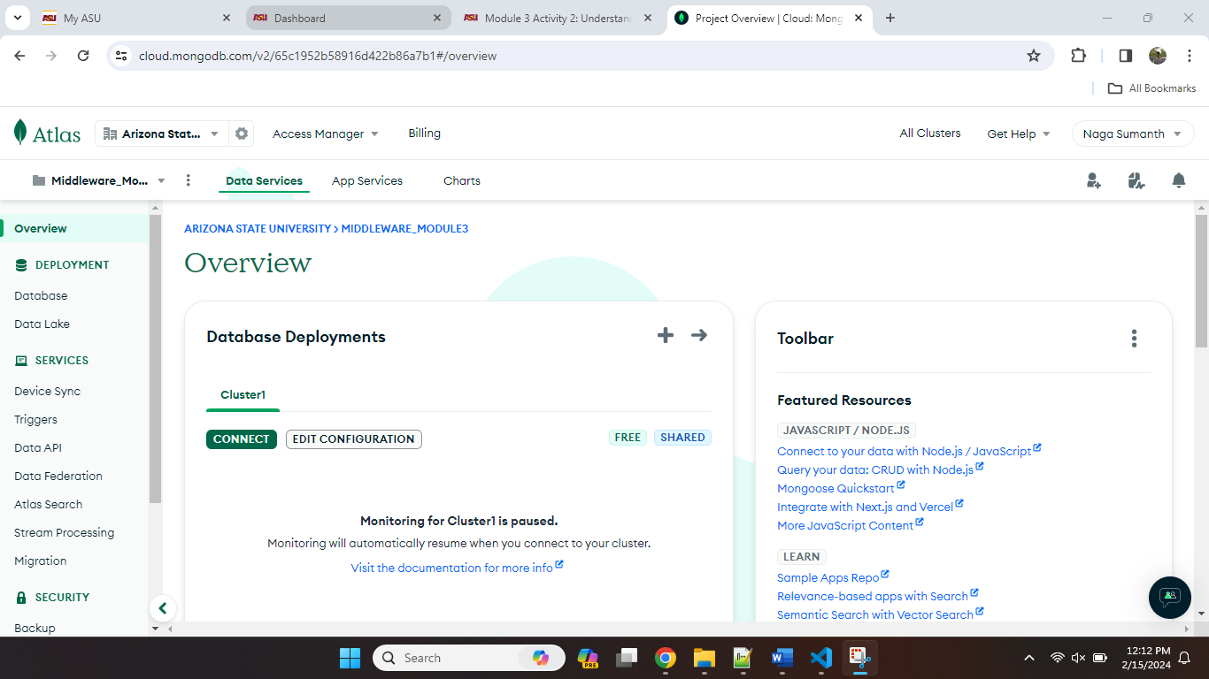

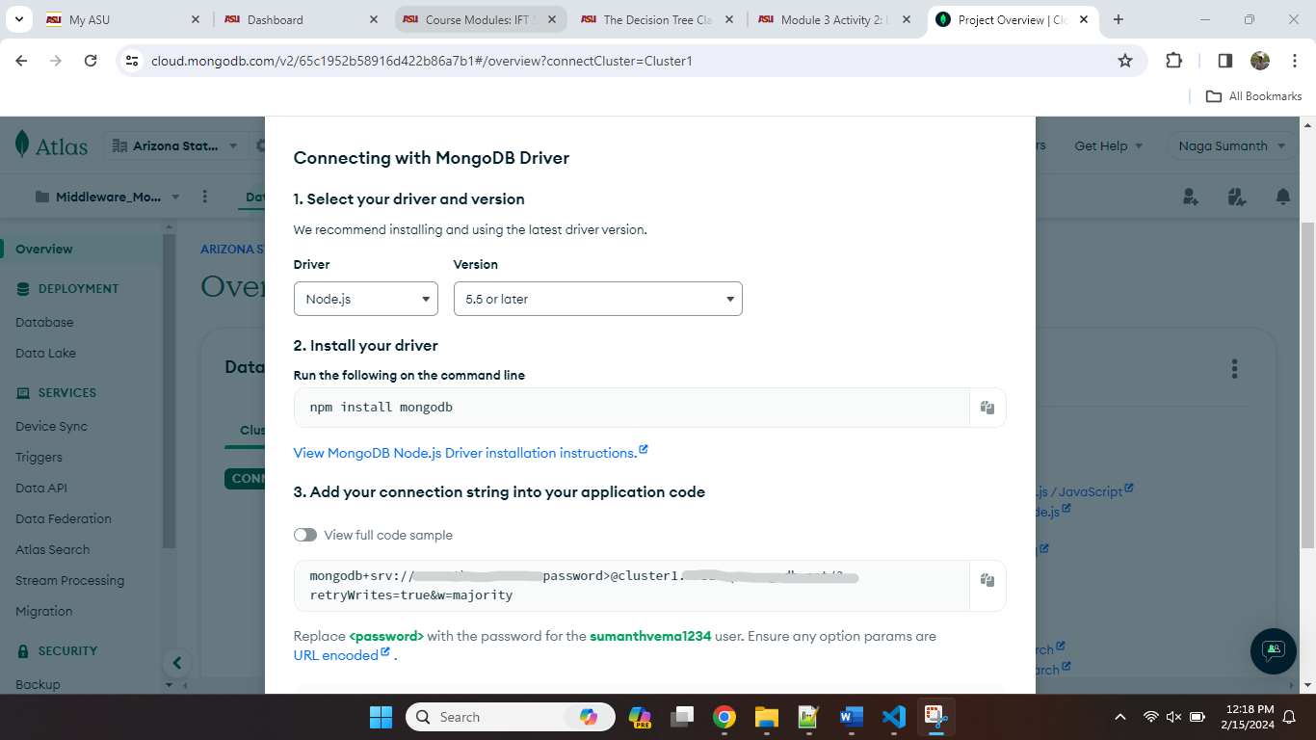

Screenshot 3: of your database.js file and terminal output showing successful connection.

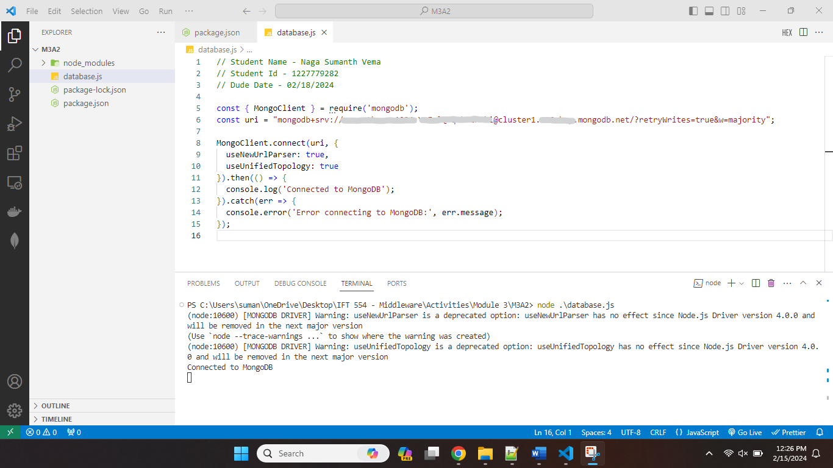

I have blurred the username and password in the above screenshot using snip tool.

Screenshot 4: of the CRUD function code, terminal commands, and results in MongoDB Atlas.

App.js File

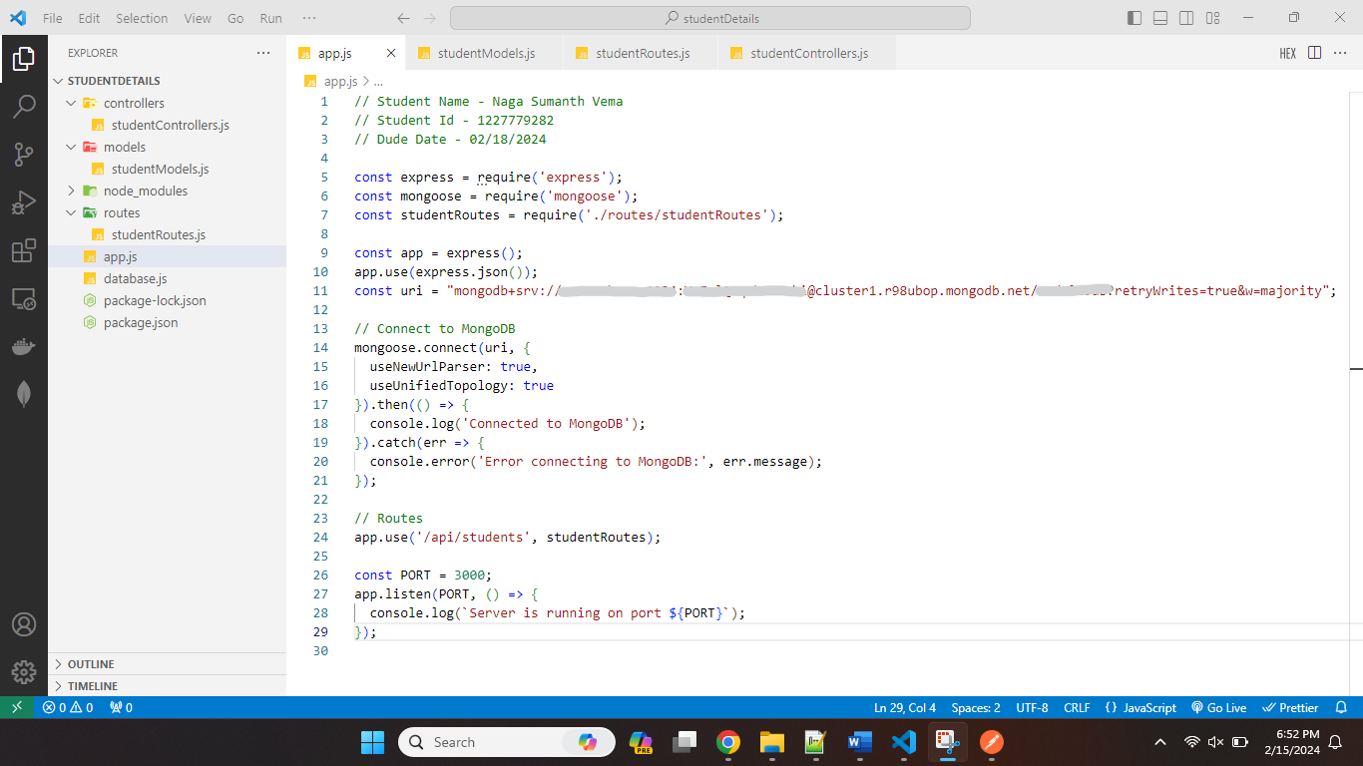

Created Database by including the name of db in the connection url.

Student Controllers:

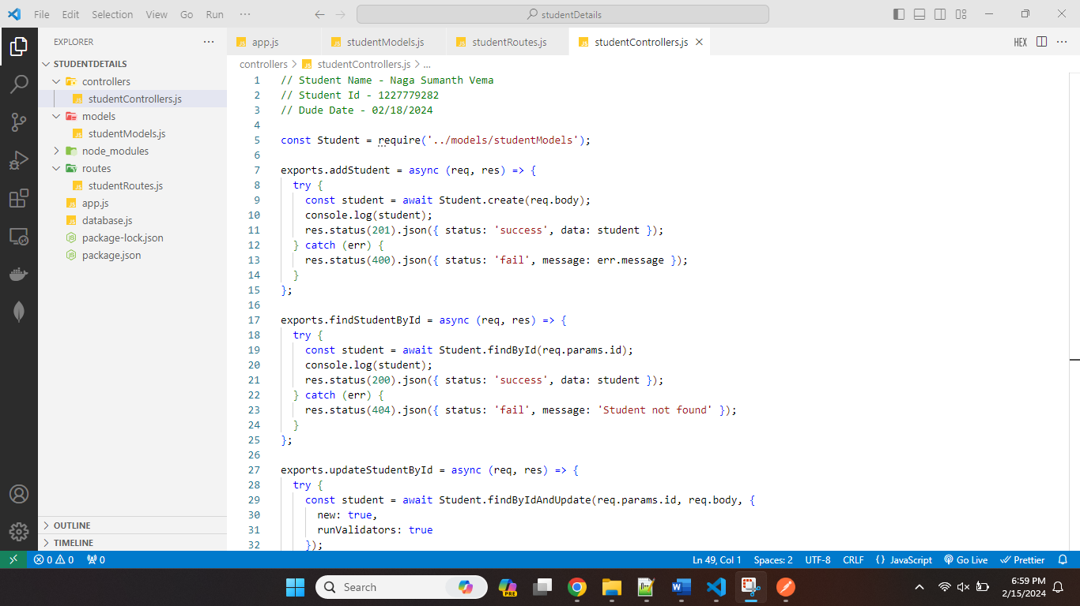

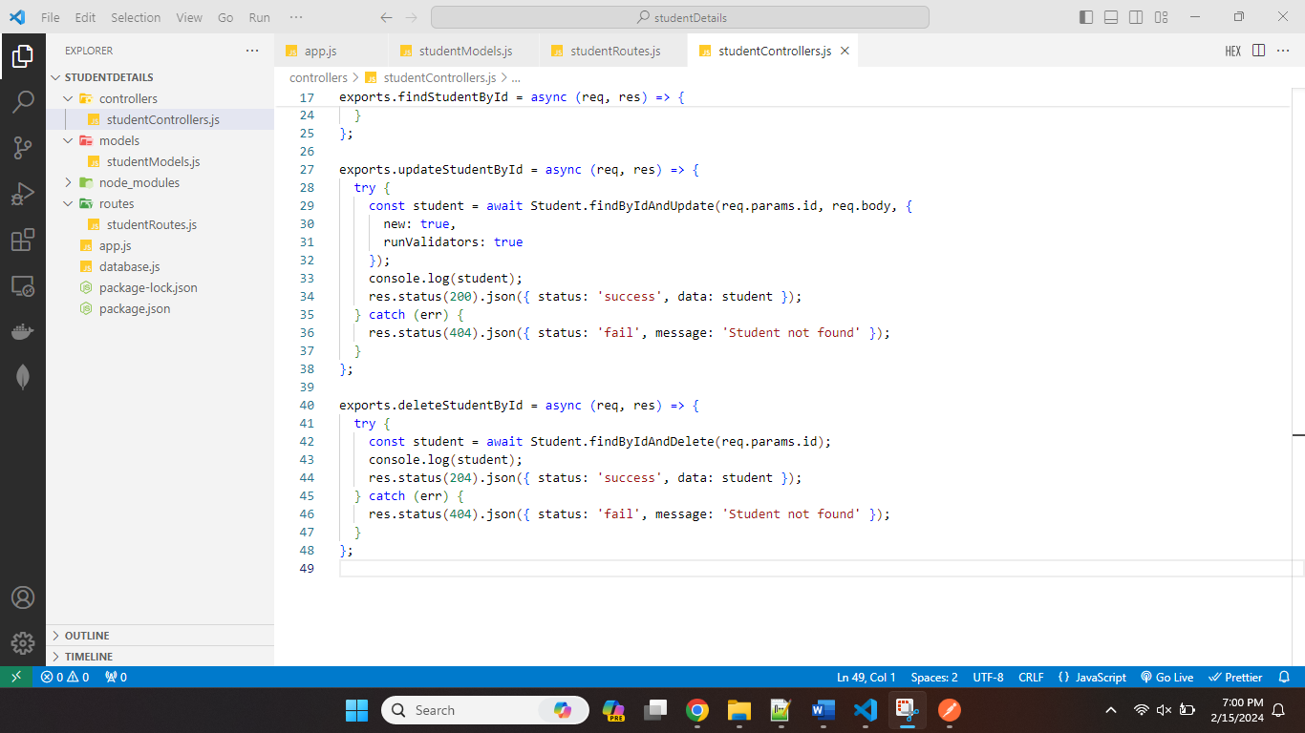

Student Routes:

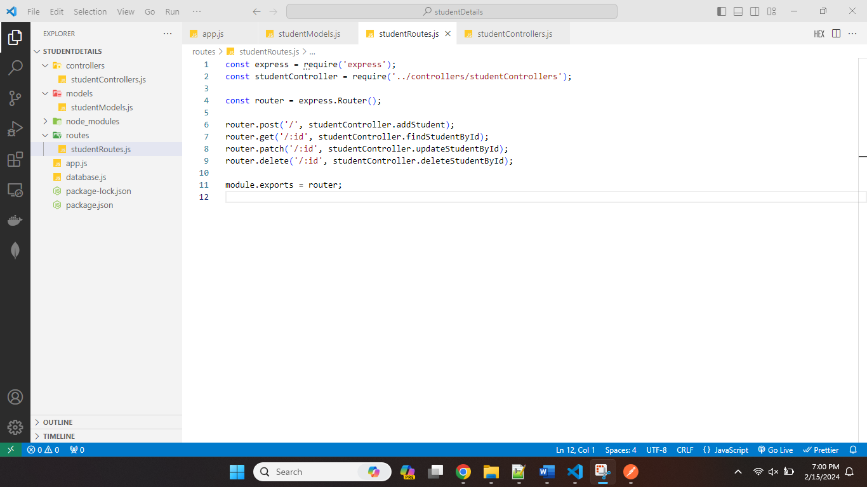

Student Model:

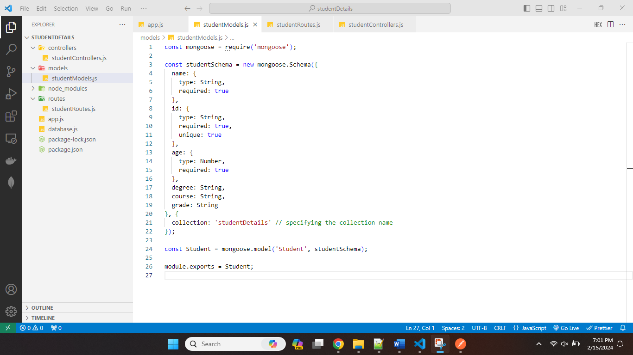

Created collection by specifying the name.

Terminal Commands: Insert

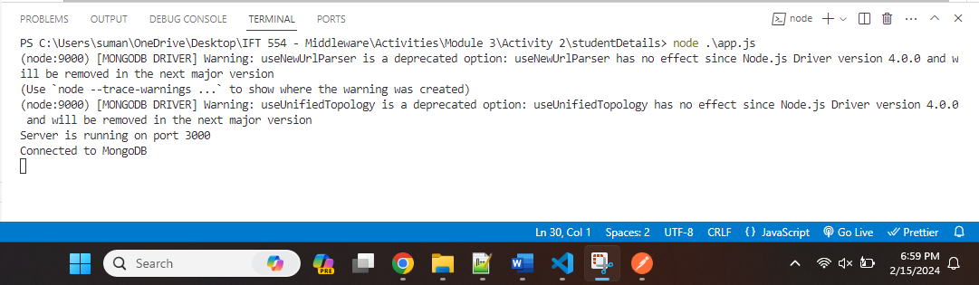

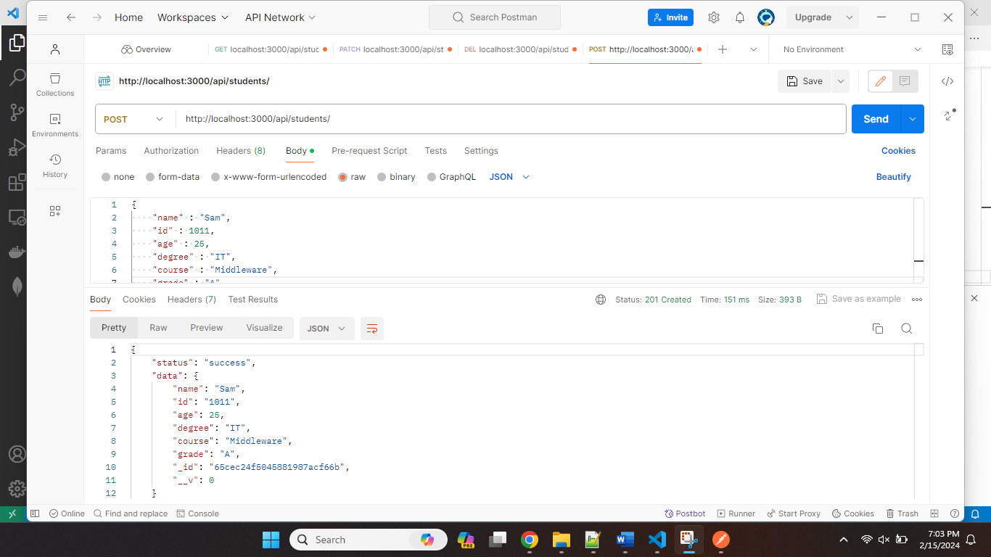

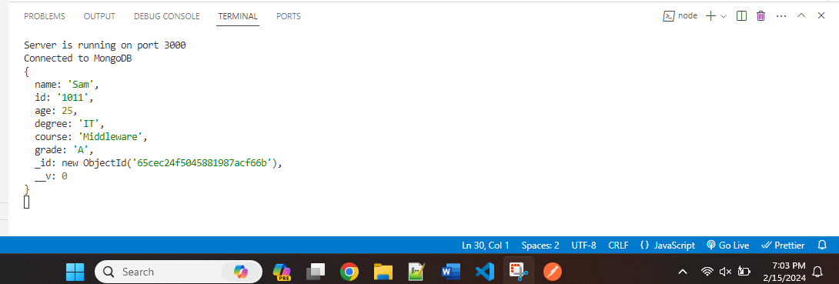

Atlas Screenshots

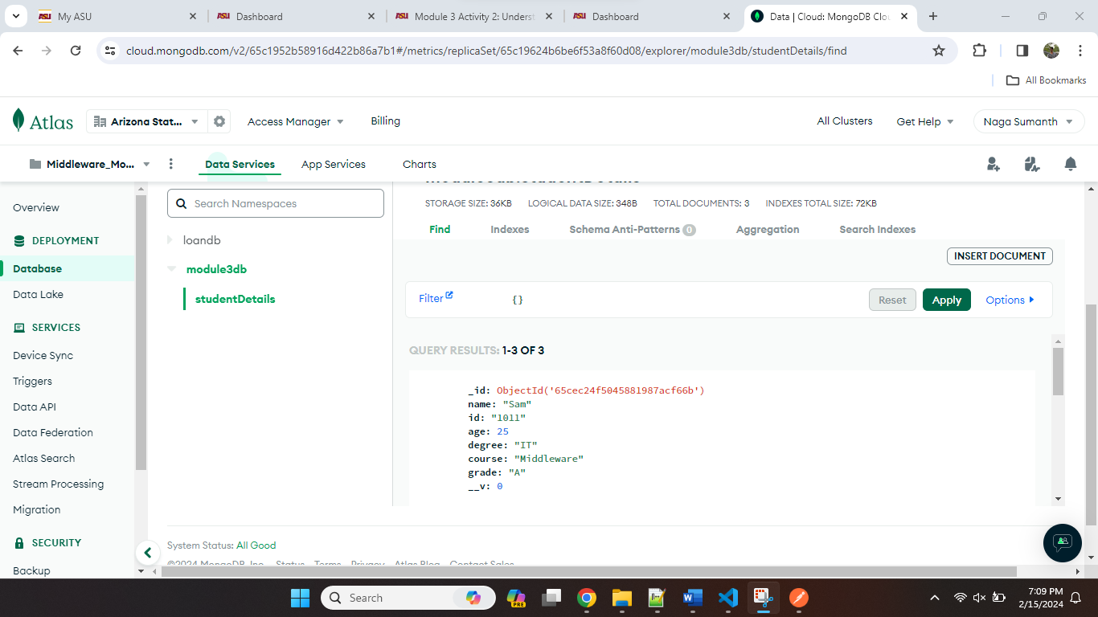

Read Document by Id:

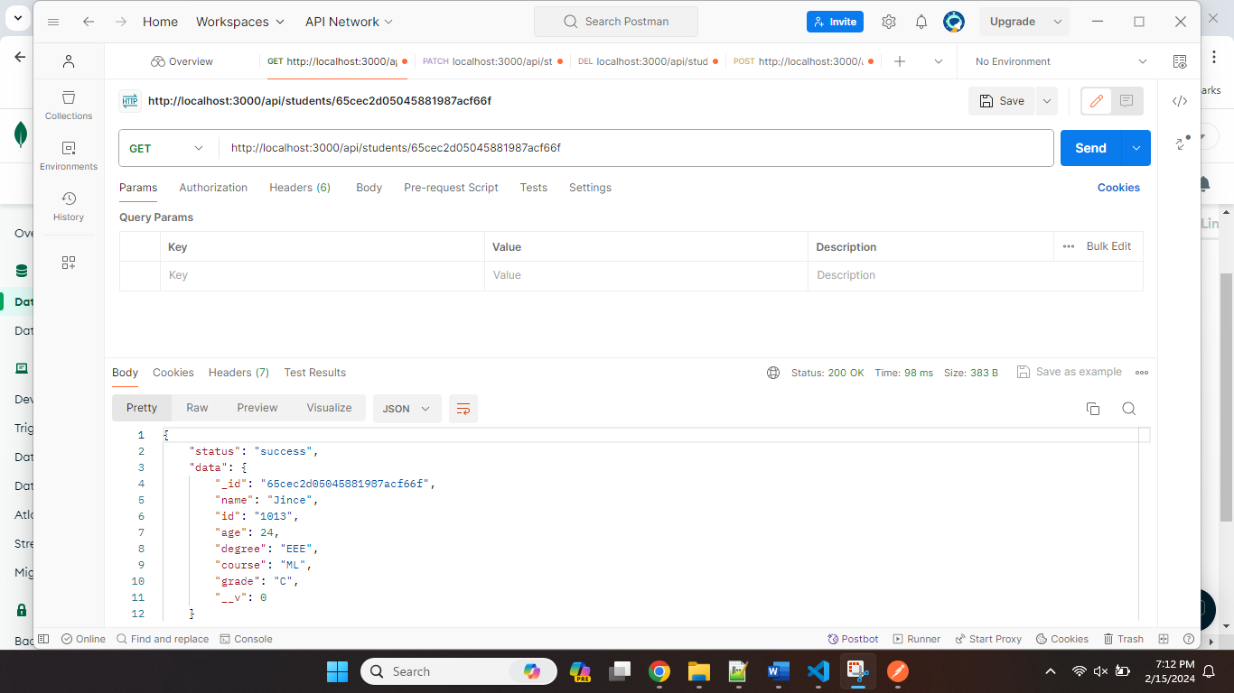

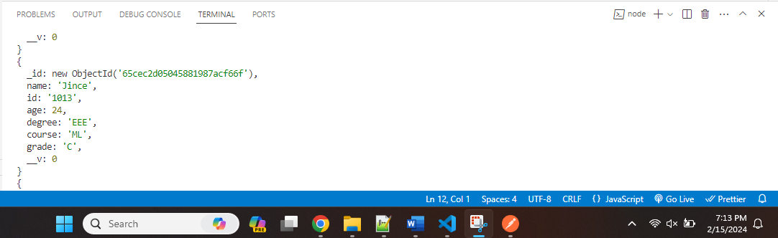

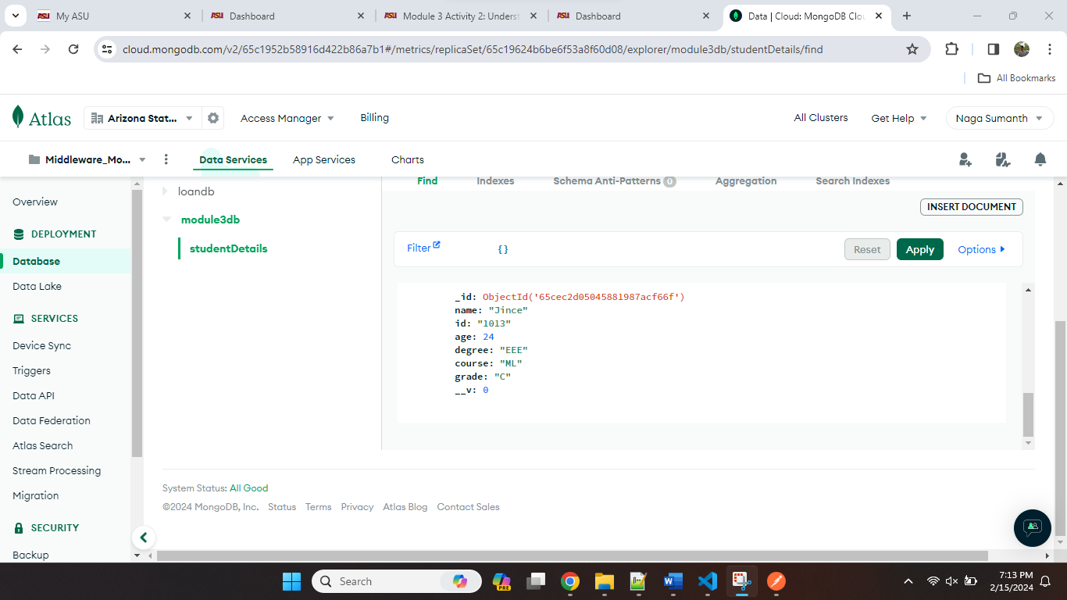

Update document by Id:

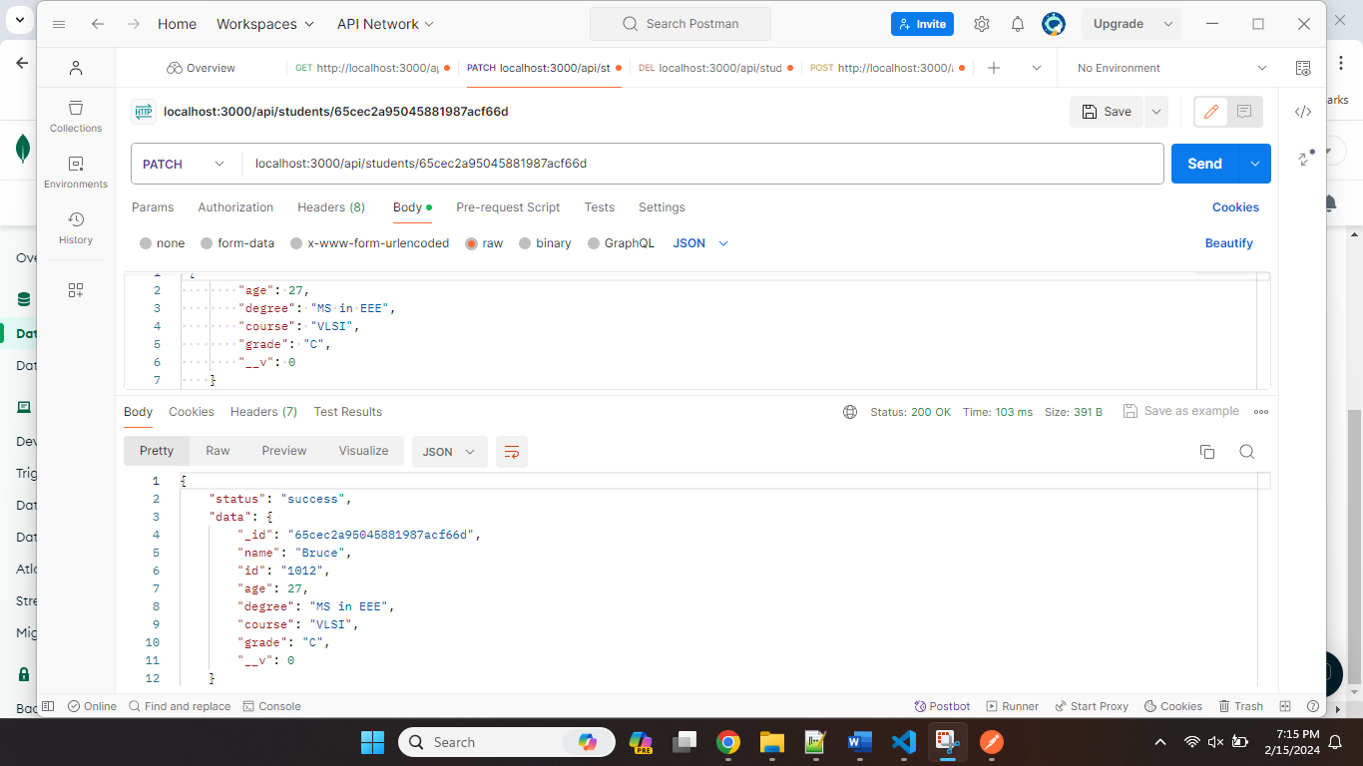

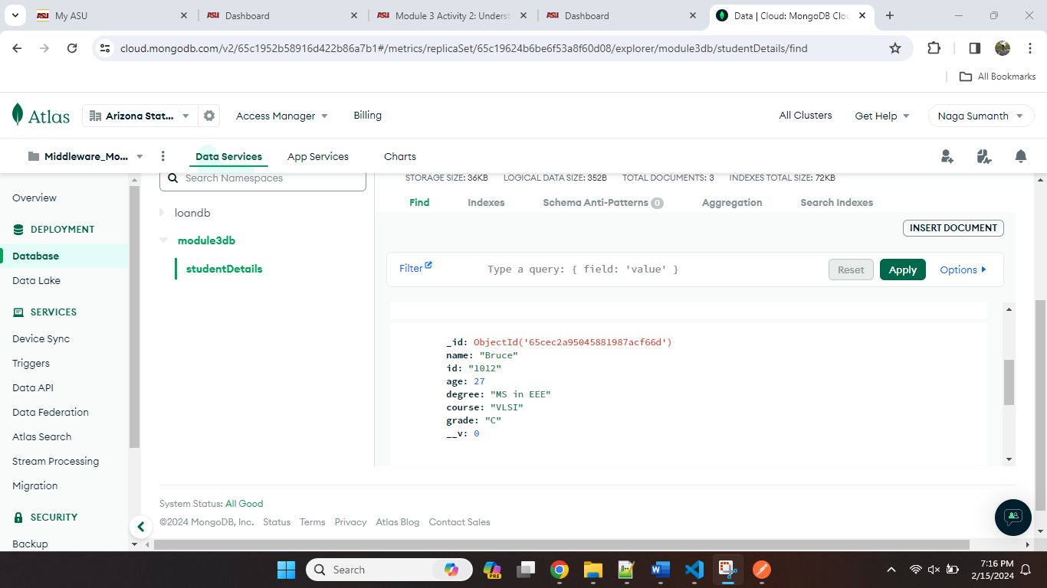

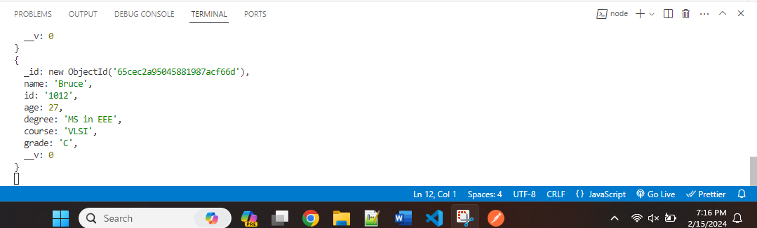

Delete document by Id:

